UNDERGRADUATE PROJECT REPORT

Project Title | Insert your project topic here. It can extend to the
 | second line if your topic is very long.
Student ID
Supervisor Name
Student Name
Student Major

Date Submitted

Declaration
Chengdu University of Technology Oxford Brookes College
Chengdu University of Technology

BSc (Single Honours) Degree Project
Programme Name:
Module No.:
Surname:
First Name:
Project Title:
Student No.:
Supervisor:
2ND Supervisor (if applicable): Not Applicable

A report submitted as part of the requirements for the degree of BSc (Hons) in Computer Science
At
Chengdu University of Technology Oxford Brookes College

Date Submitted：May 6, 2026

Student Conduct Regulations
Please ensure you are familiar with the regulations regarding Academic Integrity. The University takes this issue very seriously, and students have been expelled or had their degrees withheld for cheating in assessments. Students experiencing difficulties with their work must seek help from their tutors rather than being tempted to use unfair means to gain marks. Students should not risk losing their degree and undermining all the work they have done towards it. You are expected to have familiarised yourself with these regulations. https://www.brookes.ac.uk/regulations/current/appeals-complaints-and-conduct/c1-1/
Guidance on the correct use of references can be found on www.brookes.ac.uk/services/library, and also in a handout in the library. The full regulations may be accessed online at https://www.brookes.ac.uk/students/sirt/student-conduct/. If you do not understand what any of these terms mean, you should ask your Project Supervisor to clarify them for you.
I declare that I have read and understood Regulations C1.1.4 of the Regulations governing Academic Misconduct and that the work I submit is fully in accordance with them.
Signature: |  | Date:
Regulations Governing the Deposit and Use of Oxford Brookes University Modular Programme Projects and Dissertations
Copies of projects/dissertations, submitted in fulfilment of Modular Programme requirements and achieving marks of 60% or above, shall normally be kept by the Oxford Brookes University Library.
I agree that this dissertation may be available for reading and photocopying in accordance with the Regulations governing the use of the Oxford Brookes University Library.
Signature: |  | Date:

Acknowledgement
Here, students are allowed to thank those who have provided them with assistance and support.

Abstract
Abstract should be up to 250 words. concise outline of background, aims, results and achievements

Keywords: This is part of the “Abstract” section. Students are to provide at least 5 keywords that best describe their project topic. Do not list more than 6 keywords.

Abbreviations
xxx | Full meaning of xxx

This section should have the definition of any abbreviations used in the report.

Glossary
Term | Definitions

This section should have the definition of all the keywords you stated in the “Abstract” section. You can also define other relevant keywords. Particularly, if your final project report includes rare, unfamiliar, specialized, or made-up words or terms, the glossary serves as a dictionary for the reader to reference throughout their reading of the project report. (Note: this section should only contain definitions for specific terms in the project report. It does NOT function as an ordinary dictionary. Hence, common words related to the Computer Science and Software Engineering disciplines should NOT be included in this list.).

Table of Contents

Declaration I
Student Conduct Regulations II
Acknowledgement III
Abstract IV
Abbreviations V
Glossary VI
Table of Contents VII
Chapter 1. Introduction 1
1.1 Background of Study 1
1.2 Project Aim 1
1.3 Project Objectives 1
1.4 Project Overview 1
1.4.1 Scope 1
1.4.2 Audience 1
1.5 Structure of the Project Report 1
Chapter 2. Literature Review 3
2.1 Fundamental Theories 3
2.2 Background Review of Proposed Systems 3
2.3 Gaps in the Existing Literature 4
2.4 Summary 4
Chapter 3. Methodology 5
3.1 Problem Statement 5
3.2 Approach 5
3.3 Technology 6
3.4 Project Version Management Plan 6
3.5 Summary 6
Chapter 4. Implementation and Results 7
4.1 Performance Comparison of Proposed Framework with Baselines 7
4.2 Ablation Study Results 7
4.3 Efficiency Comparison Results 9
4.4 Summary 9
Chapter 5. Professional Issues 10
5.1 Project Management 10
5.2 Risk Analysis 10
5.3 Professional Issues 10
Chapter 6. Conclusion 11
6.1 Findings and Conclusions 11
6.2 Limitations of your Project 11
6.3 Potential Future Work 11
References 12
Formatting Requirements 12
Written Presentation 13
Appendices 14

Chapter 1. Introduction

Background of Study
This section should describe the overview of the topic and motivations. Provide appropriate references wherever necessary.

Project Aim
The overall goal of your project should be stated here. It is recommended that each project should have a single aim.

Project Objectives
Students are to state the several tasks/steps that would help them to accomplish the overall aim/goal of their project. The objectives should be well-written in full sentences. Avoid using short phrases.

Project Overview
State a brief overall description of your project here.

1.4.1 Scope
The scope for a research-oriented project eg. machine learning/deep learning-based projects should focus on answering the questions: what is the purpose of the study? How significant is the study?

1.4.2 Audience
The audience for a research-oriented project eg. machine learning/deep learning-based projects should focus on who will benefit from the findings.

Structure of the Project Report
These sections should briefly tell us how the project report is structured. What are we expecting on each chapter and so on? Summarise with a figure like what is should in Figure 1_1.
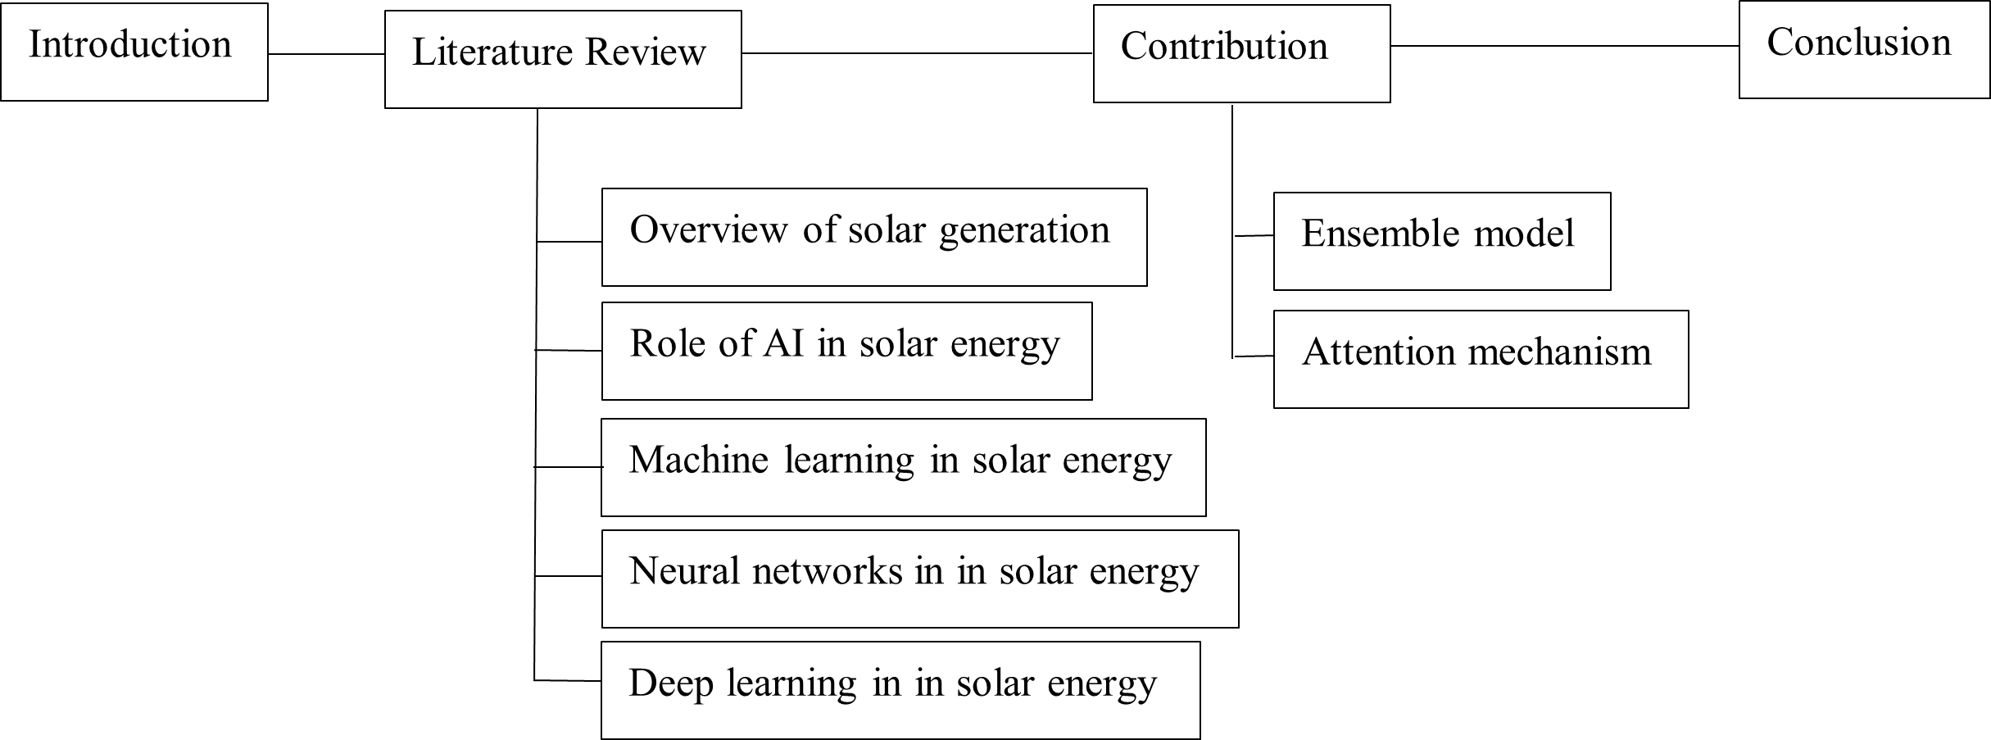
Figure 1-1. Thesis structure flowchart

Chapter 2. Literature Review
These chapter should include the main theoretical explanations that uncovers the selected topic.
This chapter is an update of the Background Review from your previous reports, using the feedback you received from your supervisor. Compare existing approaches and include a themed literature review, with a critical appraisal of the sources. Provide appropriate and sufficient references. Also include the feedback you received from your supervisor. You can add any additional key sources that you have discovered.

Students doing research-oriented projects (machine learning & deep learning projects) can write their background review by stating a summary of related literature (e.g., annotated bibliography, or initial literature review, with a brief summary of sources).
Annotated Bibliography aids as in doing a good literature review. It is not the literature review. However, your final background review must be paragraphs with appropriate citations. Whenever appropriate, a table can be adopted.

Fundamental Theories
In this subsection, you must introduce the foundational theories and terms of your projects. This greatly enhances the readability of your work to any reader. NB: The subtitles should be modified to match the concepts that are in line with your project topic.

Background Review of Proposed Systems
Briefly describe what we should expect in the proceeding subsections. NB: The subtitles should be modified to match the concepts that are in line with your project topic.

Review of Traditional Frameworks
Here you review thoroughly one category of the literature you are focused on. Subsubsections should follow this structure. NB: The subtitles should be modified to match the concepts that are in line with your project topic.

Review of Current Frameworks
Here you review thoroughly another category of the literature you are focused on. Equations should follow this structure in all the project reports and the equation numbering should be based on the Chapter.
Examples of Equations, figures and Table numbering in Chapter one should have (1-1), (1-2) etc, Chapter two should be (2-1), (2-2), (2-3), Chapter three should be (3-1), (3-2), (3-3) NB: The subtitles should be modified to match the concepts that are in line with your project topic.  $$Y_{t}=c+\sum_{i=1}^{p}{ϕ_{i}}Y_{t-i}+\sum_{j=1}^{q}{θ_{j}}ϵ_{t-j}+ϵ_{t}$$ | (2-2)

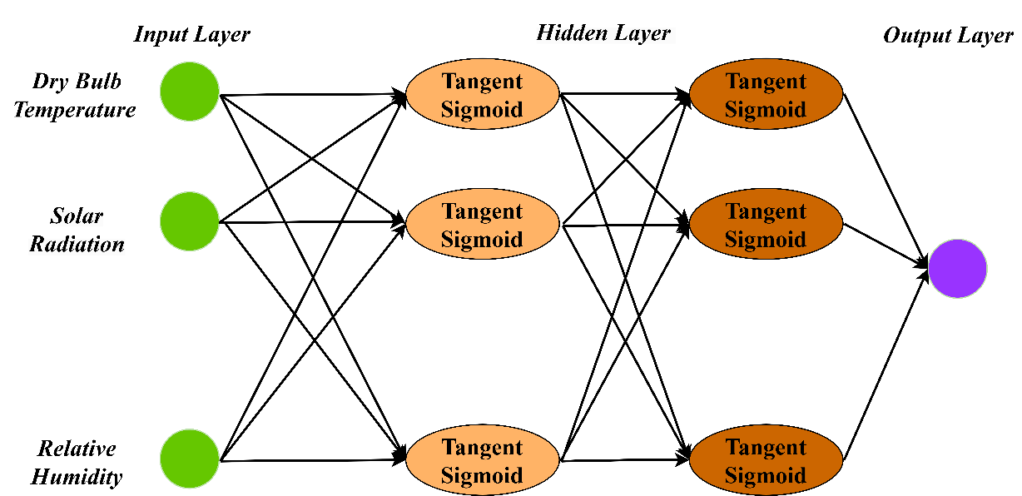
Figure 2-1. Sample of Image

Gaps in the Existing Literature
Summarizes the research gap and what you are proposing
.

Summary
This chapter briefly discussed XXXXXXXXXX.

Chapter 3. Methodology
Write a brief introduction to this chapter here [172].

Problem Statement
Clearly describe the problem you are trying to solve regarding your specific topic. Ensure it is clear for all readers to comprehend.

Approach
The approach for a research-oriented project eg. machine learning/deep learning-based projects should focus on describing the core machine learning model to be employed. Describe the mathematical basis, the algorithm details, and the optimization strategy, if applicable. Also, describe the datasets and data processing techniques to be used where relevant.

Mathematical Basis
Describe the mathematical basis here.

Overview of Model Architecture
Describe the model architecture here.

Dataset and Data Processing
Describe the dataset you will be using here and the data processing techniques you intend to employ here.
Table 3-2. Format of Table
K-Fold Validation | RMSE | R² | MSE | MAE
1 | 0.013 | 0.988 | 0.001 | 0.004
2 | 0.014 | 0.986 | 0.001 | 0.005
3 | 0.013 | 0.988 | 0.001 | 0.004
4 | 0.013 | 0.989 | 0.000 | 0.004
5 | 0.013 | 0.988 | 0.001 | 0.004
Average | 0.013 | 0.988 | 0.001 | 0.004

Technology
State all the implementation tools & resources, such as hardware and software that have been adopted for your project.
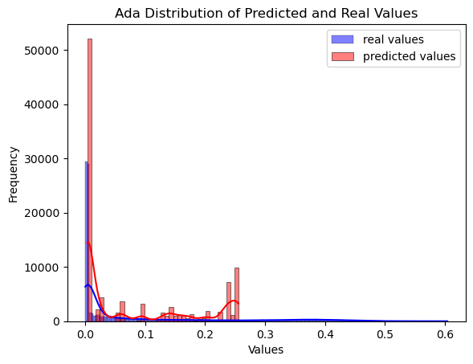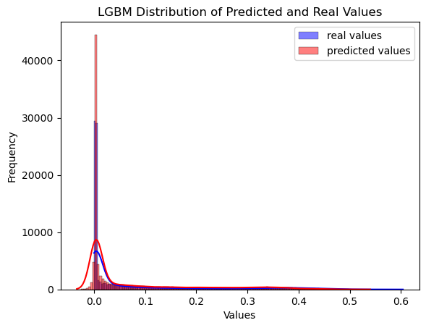
A.) AdaBoost B.) LGBM
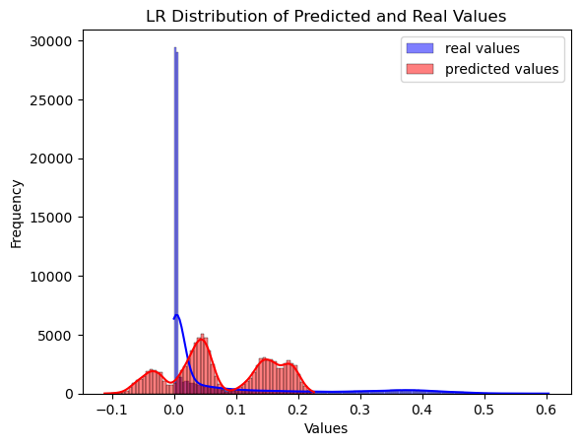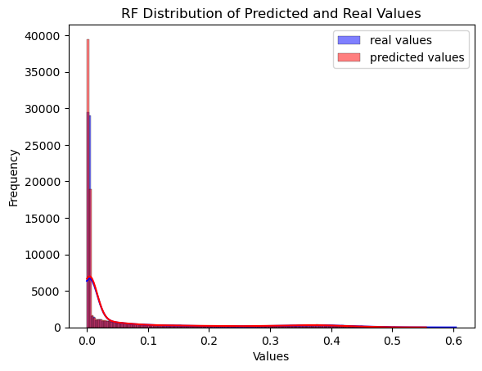
C.) Linear Regression D.) Random Forest
Figure 3-15. Format of Double Image

Project Version Management Plan
In this section, students must describe how they have used resources such as Baidu drive, Gitee, etc., to manage their project source codes. The link to the full project source should be provided.

Summary
Briefly state the main summary of this chapter here.

Chapter 4. Implementation and Results
Here students are to provide detailed descriptions and documentation of results and testing. Critical evaluation and discussion of results, issues encountered constraints, limitations, and originality.
The subsection layouts of this section mostly depend on the type of project that the student is carrying out. Students can introduce subsections that will help the readability of their work.
Students doing research-oriented projects (machine learning & deep learning projects) should state the results of their model training, validation and testing. Use appropriate graphs and figures to illustrate your results. Results from case studies and ablation study of hyper-parameters should be stated here. In a situation where a machine learning-based project was deployed as a web or mobile application, students are to provide details of functionality tests.

Performance Comparison of Proposed Framework with Baselines
This is an example of a subtopic you can explore in this chapter. NB: The subtitles should be modified to match the concepts that are in line with your project topic.

Ablation Study Results
This is an example of a subtopic you can explore in this chapter. NB: The subtitles should be modified to match the concepts that are in line with your project topic.

Effects on the Removal of Component 1
This is an example of a subtopic you can explore in this chapter. NB: The subtitles should be modified to match the concepts that are in line with your project topic.

Effects on the Removal of Component 2
This is an example of a subtopic you can explore in this chapter. NB: The subtitles should be modified to match the concepts that are in line with your project topic.
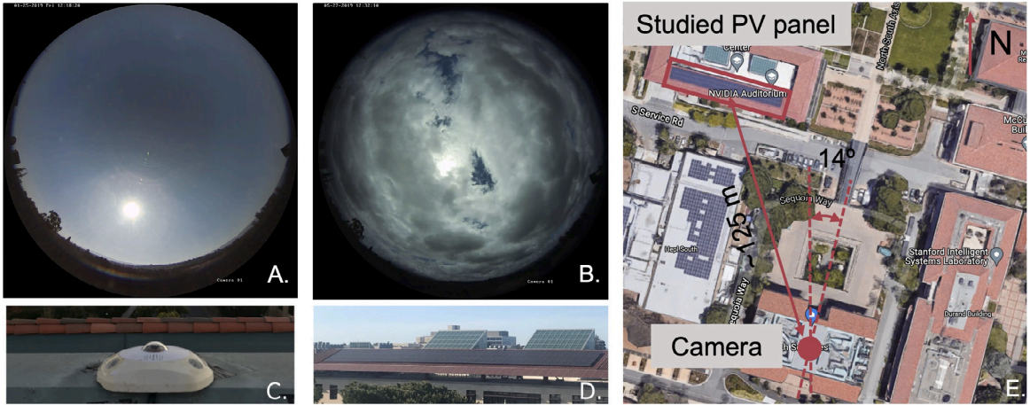
Figure 4-2. xxxxxxxxxxxxxxx
.
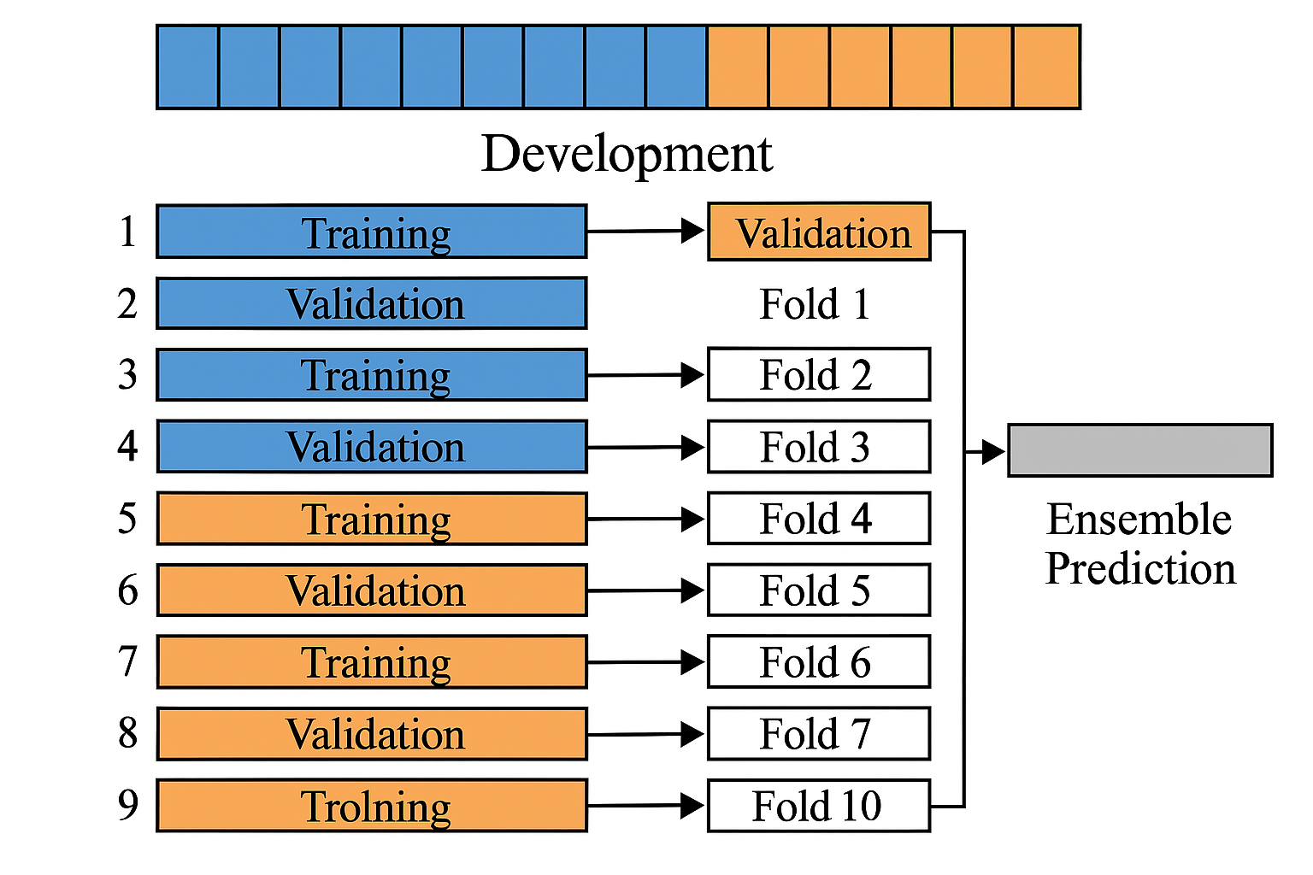
Figure 4-5. 10 xxxxxxxxxxxxxxx;
$$MAE=\frac{1}{n}\sum_{i=1}^{n}{|y_{i}-{\hat{y}}_{i}|}$$ | (4-12)
$$MAPE=\frac{1}{n}\sum_{i=1}^{n}{\left|\frac{y_{i}-{\hat{y}}_{i}}{y_{i}}\right|}×100$$ | (4-13)
$$RMSE=\sqrt{\frac{1}{n}\sum_{i=1}^{n}{(y_{i}-{\hat{y}}_{i})}}$$ | (4-14)
$$R^{2}=1-\frac{\sum_{i=1}^{n}{(y_{i}-{\hat{y}}_{i})^{2}}}{\sum_{i=1}^{n}{(y_{i}-\overline{y})^{2}}}$$ | (4-15)
$$MSE=\frac{1}{n}\sum_{i=1}^{n}{(y_{i}-{\hat{y}}_{i})^{2}}$$ | (4-16)

Efficiency Comparison Results
This is an example of a subtopic you can explore in this chapter. NB: The subtitles should be modified to match the concepts that are in line with your project topic.
Table 4-2. Overall Performance Comparison
Metrics | Overall | Sunny Days | Cloudy Days
RMSE | 2.259 | 0.461 | 3.158
MSE | 5.104 | 0.212 | 9.975
MAE | 1.237 | 0.353 | 2.117
MAPE | 0.741 | 0.587 | 0.895
R² | 0.913 | 0.996 | 0.824
- .

Summary
Here state the final takeaways from this chapter.

Chapter 5. Professional Issues

Project Management
Introduce this chapter briefly here.
    - Activities
State the complete tasks for each objective. The details here can be presented by a table.

Schedule
In this section, you can use a Gantt chart or other charts to show the activities and their deadlines. Highlight all completed tasks in the project schedule chart.

Project Data Management
In this section, students must describe how they have used resources such as Baidu drive, Gitee, etc., to manage project logs, reports, literature, etc

Project Deliverables
In this section, briefly list all the documents and project resources that have been submitted for assessment. Example: Project proposal, progress report, final report, project code/ software, poster presentation file, etc.

Risk Analysis
Risk analysis as informed by the current project progress; Resolved risks and the success of the mitigation strategy; Changes to the project plan as a result of risks; Future risks.

Professional Issues
Identification and discussion of relevant legal, social, ethical, and environmental issues in the context of the project. Refer to professional codes of conduct, e.g. BCS, ACM.

Summary
State a brief summary of the main takeaways of this chapter here.

Chapter 6. Conclusion

Findings and Conclusions
Summary of what was achieved and your findings here.

Limitations of your Project
State the key limitations of your work here

Potential Future Work
Highlight potential future works here.

References
- The layout above is a suggestion of how to present your Final Project Report. Whenever appropriate, introduce sections that will help the readability of your work.
- The Length of the final report should be 8000 – 10000 words.
- All sections and subsections should be numbered for cross-referencing purposes.
- Regarding citations and references, students must adhere to the University guidelines or IEEE referencing style. Students doing software development-based projects can cite related websites, web applications, developer documentation, etc. They can cite related articles to their projects, but it is not required. Students doing research-oriented projects should focus on citing research articles. They can also cite appropriate websites whenever necessary. Students are advised to use appropriate reference management software such as Mendeley Reference Manager or Zotero to ensure the correctness of all references.

Formatting Requirements
Your written report must be presented in the following format:
- All main sections/chapters should begin on a new page. The Declaration page, Tables of Contents pages, Acknowledgment, Abstract, Abbreviation, Glossary, Project Chapters (Chapters 1 to 6), and Appendices should all start on a new page.
- It must be word-processed in 11-point Arial font.
- It must be black text on a white or ivory background
- All pages must be numbered. Follow the appropriate page numbering format specified in the template.
- Margins must be as follows: Top: 1 inch, Bottom: 1 inch (2.5 cm), Left: 1.25 inches, Right:
- 1.25 inches (3.2 cm)
- Use a line spacing of 1.5
- Numbers and captions to figures should be at the bottom of the figure. If the figure is mounted sideways into the report, then its bottom is on the right-hand side of the report. All figures must be well labeled.
- Numbers and captions to tables should be at the top of the table. If the table is mounted sideways into the report, then its top is on the left-hand side of the report. All tables must be well labeled.
- Normally, the report should not contain more than 80 tables/figures.

Written Presentation
- The final project report must have a concise written presentation and referencing style.
- It should also have a clear & logical presentation.
NOTE:
- All the text in red colour are basic guidelines and must be DELETED after using this guide.
- Finally, update the “Table of Contents” appropriately to display the correct section titles and corresponding page numbers.

Appendices

This section can have the essential information/data that are necessary to be included within the report but would disrupt the flow of the main argument. This section is not marked. Examples include links to data and software repositories, questionnaires, raw survey results, and wireframes

